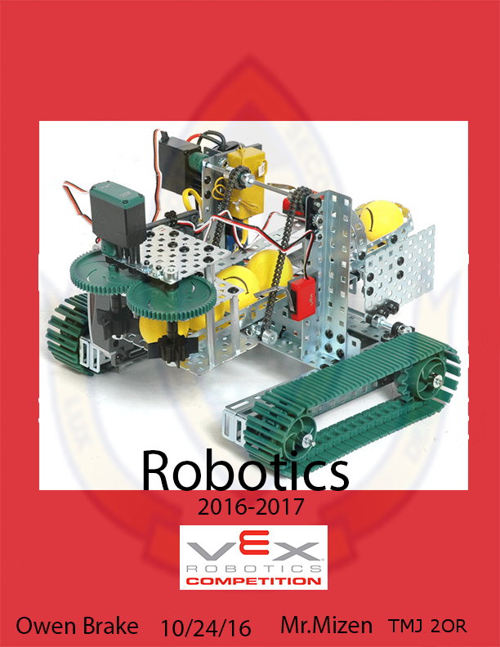

Written Report

A)

**PWM**

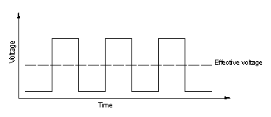Pulse Width Modulation (PWM) is a method to encode a message as a pulsing signal. This is used in Vex Robotix where a current from a battery is sent through a motor controller. Which is turned on and off at extremely fast rates. This is then averaged so the motor knows how quickly to turn the motor. So if half the time the pulses are on and half off then the motor will turn at about half the speed. This helps the power efficiency since motors tend to require a lot of current so by only sending quick short signals would be better than sending one long signal.

**Linear Power Motors**

Some Motors may not use PWM even for the power efficiency. In this method current is sent directly to the motor and would often have resistors or potentiometers to control how much power is provided and how fast the motor will spin however this is inefficient and pointless. However having linear power motors are cheap and are 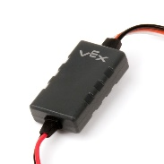often used in cheap toys.

**Motor Controller**

Motor Controllers are attachments between motors and the Vex Cortex which converts the signals into PWM. The motor controller also instead of having an output of 2 wires it has 3 wires into the cortex.

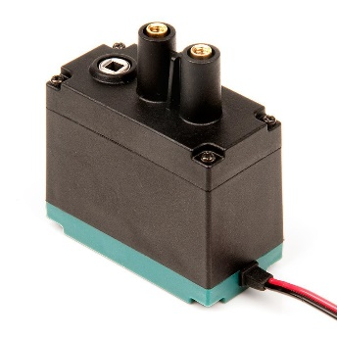B)

**DC Motor**

A DC Motor when provided power turns it is that simple it turns when it is provided current. They tend to have a motor controller using PWM to make it power efficient. These motors can spin 360o however they are fairly inaccurate since the signal sent to the motor controller does not specify a degrees it simply tells it how long to rotate for which is not great for advanced machines like arms. Though it is inaccurate the DC Motor has a very high RPM which is a significant advantage compared to other motors. The DC motor in Vex has three I/O ports Power, Ground and Output when you provide power to the Power terminal the output spins. A DC Motor would be used in automobiles for their wheels providing high RPM with 360o of motion it would also be used in power tools for the exact same reasons.

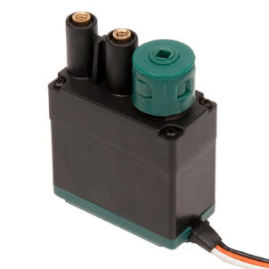**Servo Motor**

A Servo Motor however is accurate and has parts that detect position which can allow devices to set the exact degrees. This is good for some machines since it is accurate however it cannot go a full 360o­ only 100o which limits its usage. The servo also has a lower RPM. The Vex servo motors have 3 I/O ports (Figure 2.) Power, Control and Output the extra Control input is for controlling what degrees to rotate the motor and power is just current provided to motor. A Servo motor would be used for moving a robotic hand since

C)On paper

D)On paper

E)

1) Torque is the force acting on an object which causes that object to rotate. Rather than the number and speed of revolutions in an allotted time. Torque is measured in newton meters, while speed of the motor is 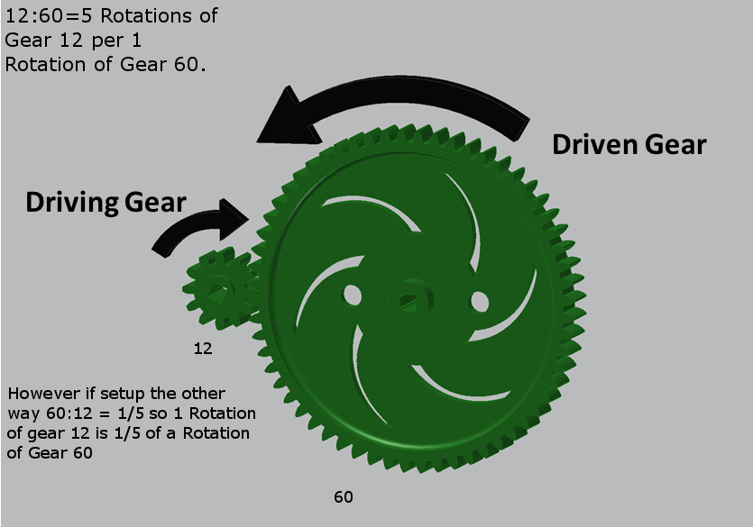measured in Revolutions per Minute (RPM).

2) As you can see in the image with the motor attached to gear 60(driving gear) then gear 12(driven gear) spins 5 times for every 1 time that gear 60 rotates so this will prioritize speed over torque with gear 12 moving quickly but it does not have a lot of force. You also notice if you reverse the setup with the motor connected to gear 12(driving gear) then gear 60(driven gear) will spin about 1/5 of the way for every 1 time gear 12 spins.

3) We can calculate the increase in rpm of the driven gear by using the gear ratios. To calculate the increase/decrease of rpm you must divide the driving gears number of teeth by the driven gears number of teeth and multiply that by the motors rpm. For example if you have a gear with 1 tooth as the driving gear and a 3 tooth gear as the driven gear for every turn of gear 1 the 3 tooth gear spins 1/3 of the way. With this gear setup if you have a motor spinning at 200 rpm then 200 rpm x 1/3 ratio will give you 80 Revolutions so the driven gear will spin at 80 revolutions per minute though it has a slower rpm it will have more torque. However this does not fully include all the factors there are other factors like the smoothness of the teeth or other environmental factors.

F)

1) The 8-32 fasteners name can be broken into 2 parts 8 and 32 this is known as Unified Thread Standard a standard for measuring threaded objects in our case we are using a UNC Threaded Object. The 8 is the major diameter which is the diameter from the peak of the 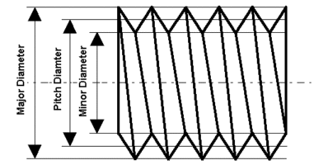threads. In our case 8 is standardized as 0.164 inches so now we know the major diameter is 0.164 inches. The 32 stands for the Threads per inch so if you count the number of threads on one side then there will be 32 in 1 inch. This would be used to fasten large objects together such as the chassis to the arm of the robot or attaching different metal c-channels together.

2) 6-32 uses the same standard an 8-32 major diameter-threads per inch in our case 6 is our major diameter and 32 our threads per inch. With the same classification as 8-32 UNC. So 6 is 0.138 inches as our major diameter. While 32 is our threads per inch so 32 threads per inch.